# Digital transformation Journey of The New York Times Company

The New York Times (NYT) is an example of an organization that seems to have been taking the right steps to transform itself and transition to a digital landscape. Unlike many incumbents who have been swept away by the tides of digital disruption, the New York Times has been gradually transforming itself for the past few years and now seems to be positioned firmly to compete in the digital world. It mainly competes with other U.S. and global news and information websites, mobile applications and digital products, including The Washington Post, The Wall Street Journal, CNN, BBC News, Vox, Buzzfeed, NPR, The Guardian and Financial Times. Now, I would like to highlight some of the important aspects from NYT digital transformation journey and its strategy to withhold its position in media market.

The NYT was incorporated on August 26, 1896, under the laws of the State of New York. It is a global media organization focused on creating, collecting and distributing high-quality news and information. The continued commitment to premium content and journalistic excellence makes NYT brand a trusted source of news and information for readers and viewers across various platforms. Its main core products include,

* The New York Times (“The Times”), which is available on mobile applications, website (NYTimes.com), NYT on Kindle and as a printed newspaper, and also on associated content such as podcasts.
* Its other interest-specific products, including NYTimes Crossword, NYT Cooking and Audm (our read-aloud audio service), which are available as a mobile application or a website
* Wirecutter, an online review and recommendation product
* It’s related businesses, such as its licensing operations, creative services associated with our branded content studio

The business model under its success was “subscription-first” and they currently have 7.5 million paid subscriptions at the end of 2020. As the first step towards digital transformation, NYT instead of being aggressive and changing its business model, it observed and analyzed the competitors on how they are providing service and its impact. Then, it started focusing on its core competency of journalism and continued to produce quality reporting and analysis on a wide number of topics. This impacted in large subscription growth and brought good popularity among customers.

Further, it continued its digital journey by exploring new options of revenue growth. As a result, it took advantage of its core strength of content and started exploring multiple platforms to extend the availability of its product. The annual revenue report of that year gave them confidence to their digital strategy. So, they started concentrating on new digital technology available in the market and tried to integrate with it as much as possible. This resulted in great availability and increased the reach to customer.

In addition, NYT decided to put its old content from many decades earlier online and opened their access to its paid subscribers. This enabled the organization to increase the value of its overall products and services and gave more reasons to its subscriber base to visit its website.

As media industry continues to shift from print to digital media, it’s products face competition for audience, subscriptions and advertising from a wide variety of digital media (many of which are free to users), including news and other information websites and mobile applications, news aggregators, sites that cover niche content, social media platforms, podcast distributors, and other forms of media.

Further, The New York Times Company moved more into lifestyle journalism, with online products like Cooking, Multimedia and Wellness. In addition, it had made another bet on so-called service journalism, with the acquisition of the product recommendation site ‘**The Wirecutter’**. This acquisition comes at a time of transition for The Times, which is attempting to reconstitute itself for the digital future.

NYT unlocked what digital news could be in people’s lives. And to tap that growth potential, they also continued adding digital product talent, whose work will make journalism more accessible, engaging and impactful.

While their product progress is increasingly evident to consumers, they see an improved experience for **up-to-theminute** coverage, expanded use of visual and data journalism and added new story formats. They also thought hard about expanding their subscription product portfolio.

For the next year, they tested a subscription product for Wirecutter, and experimented more aggressively with Audm, the read-aloud audio subscription service NYT acquired in mid-2020. NYT sees all of these products as a way for The Times to mean even more in people’s lives, and also to make a relationship with The New York Times brand more valuable.

Key to scaling of business will improve its culture as a company. One of The Times’s defining qualities has been its willingness to look hard at itself and identify ways to do better. In a year in which issues around diversity, equity and inclusion have been powerfully brought to the fore, there were instituting changes at The Times that made it a better place to work for all, and lead to making its business and company stronger.

They achieved two key milestones in 2020: digital revenue overtook print, and digital subscription revenue, which has long been their fastest-growing revenue stream, became largest. Together, those accomplishments, plus their best year on record for subscriptions, marked the end of the first decade of strategic transformation to a digital-first, subscription-first company. They also mark the beginning of our next decade.

The Times sold its first digital subscription 10 years ago. Since then, they have been focused on proving out their strategy of journalism worth paying for through direct-to-consumer digital subscriptions. Their target for new decade is about scaling that idea.

**Appendix:**

From the below snaps, we see that their profit growth was largely driven by a 30 percent increase in digital subscription revenue.

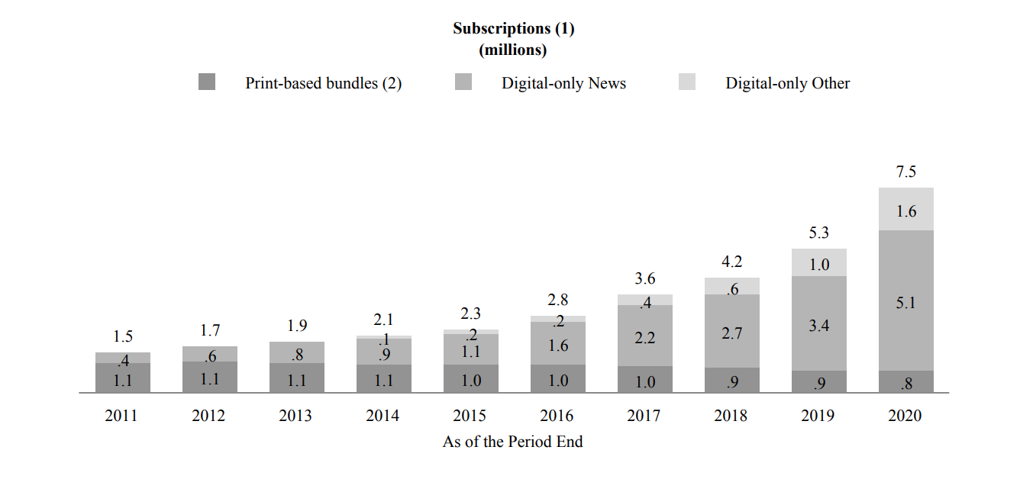

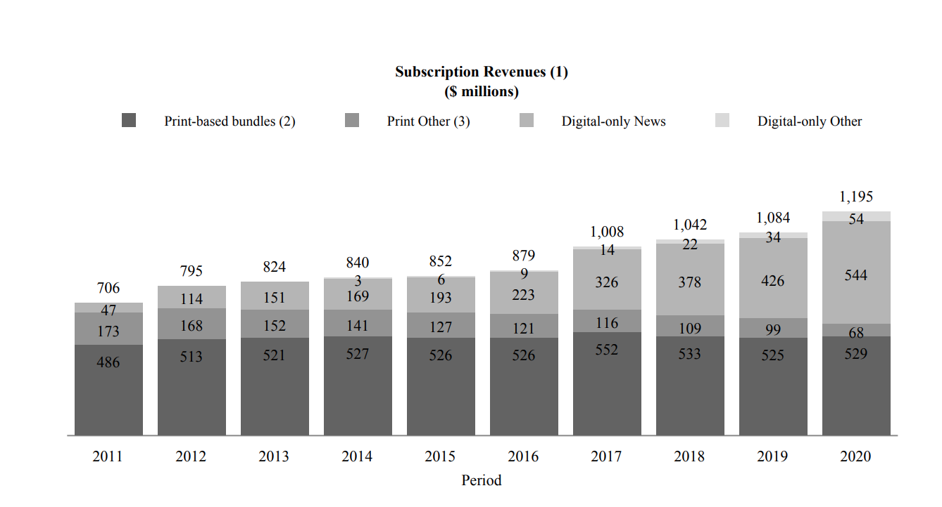

**References:**

* <https://www.nytimes.com/projects/2020-report/index.html>
* <http://www.ciotechcentral.com/nytimes-com-business-case-digital-transformation/>
* <https://nytco-assets.nytimes.com/2021/03/Final-NYT-2020-Annual-Report.pdf>
* <https://www.nytimes.com/2016/10/25/business/media/new-york-times-company-buys-the-wirecutter.html>